A blind boy sat on the steps of a building with a hat by his feet. He held up a sign which said: "**I am blind, please help**."   
一個失明的男孩坐在一個大廈的階梯上，擺了一頂帽子在他的腳旁，拿著一個告示牌寫著：「我是瞎眼的，請幫幫我」。   
  
There were only a few coins in the hat.   
帽子裡只有幾枚硬幣。   
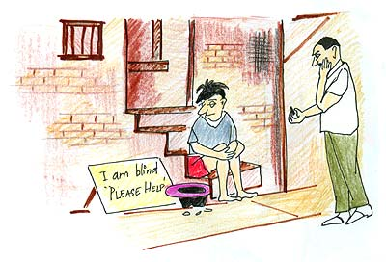  
  
A man was walking by. He took a few coins from his pocket and dropped them into the hat. He then took the sign, turned it around, and wrote some words. He put the sign back so that everyone who walked by would see the new words.   
一個男人經過了， 他從口袋裡掏出了幾枚硬幣投入帽子裡。然後，他拿起告示牌把它翻轉過來寫了一些字。他放回告示牌，以便走過的每個人都會看到新的詞句。   
  
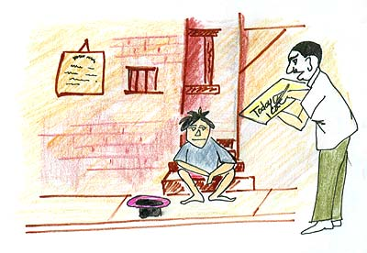  
  
Soon the hat began to fill up. A lot more people were giving money to the blind boy. That afternoon the man who had changed the sign! came to see how things were.   
帽子很快的開始填滿了錢。更多人給失明的男孩更多的硬幣。 午後，改寫了告示牌的男人來看看事情發展得怎麼樣了。>   
  
The boy recognized his footsteps and asked,  **"Were you the one who changed my sign this morning? What did you write?"**   
男孩認出了他的腳步並問：「您是不是今天早上改寫我的告示牌的人？您寫了什麼？」   
  
The man said, "I only wrote the truth. I said what you said but in a different way."   
那人說：「**我只是寫真相。 我說了你原本的意思，但用的是另一種說法。」**   
  
What he had written was: "**Today is a beautiful day and I cannot see it**."   
他寫的是： 「**今天是美好的一天，但我卻不能看見。」**   
  
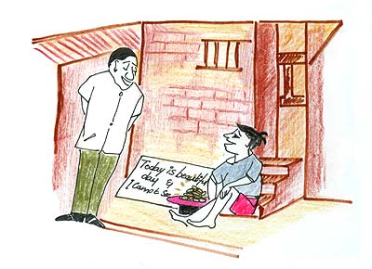  
  
Do you think the first sign and the second sign were saying the same thing?   
你認為第一個告示和第二個告示寫的是同一件事嗎？   
  
Of course both signs told people that the boy was blind. But the first sign simply said the boy was blind.   
當然兩個告示都是告訴別人男孩是失明的。   
  
But the first sign simply told people to help by putting some money in the hat.   
但第一個告示單純地告訴人投入一些錢在帽子裡以便幫助這位男孩。   
  
The second sign told people that they were able to enjoy the beauty of the day, but the boy could not enjoy it because he was blind.   
第二個告示告訴人們他們能享受美麗的一天，但男孩不可能享受它，因為他是瞎的。   
  
The first sign simply said the boy was blind. The second sign told people they were so lucky that they were not blind. **Should we be surprised that the second sign was more effective?**   
第一個告示只訴說了男孩是瞎的。 第二個告示告訴人們(自己)是多麼的幸運不是瞎眼的人。  **Moral of the Story:** Be thankful for what you have. Be creative. Be innovative. Think differently and positively.  **這故事的教誨:**要為您擁有的感謝, 要有創意, 要革新, 另類與正向思考。   
  
When life gives you a 100 reasons to cry, show life that you have 1000 reasons to smile.   
當生命給您ㄧ百個理由去哭,要展示您有一千個理由去微笑的生命   
  
Face your past without regret.   
無悔地面對您的過去   
  
Handle your present with confidence.   
以信心掌握您的當下   
  
Prepare for the future without fear.   
無懼地為將來做準備   
  
Keep the faith and drop the fear.   
保持信念和去除恐懼   
  
The most beautiful thing is to see a person smiling.   
至美的事是去看一個人微笑   
  
And even more beautiful is, knowing that you are the reason behind it !!!   
甚且更美的,是知道您是那微笑之後的原因  **The difference between the impossible and possible lies in a person's determination.**  **可能與不可能之間的差異  取決於一個人的決心**  **If you like, share it with others.**  **如果您喜歡,請把它分享給別人**